**Exercise:**



**Part 1:**

**Do the following wordsearch before starting the task:**

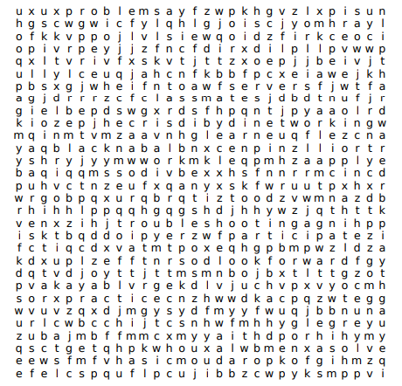



Troubleshooting

Assignments

Participate

Lab

Look forward

Networking

Classmates

Practice

Problems

Hardware

Skills

Attend

Servers

Review

Learn

Study

Solve

Apply

Work

Grab

**Read the next paragraph and answer the questions:**

**A Day in the Life of Jake, an IT Student in the US**

Jake is an IT student at a technological institute in the United States. Every afternoon, he attends lectures where he learns about programming languages, networking, and cybersecurity. Before class, Jake spends the morning working on coding assignments and practicing what he learns. He often studies with his classmates to solve complex problems together. During lunch, Jake grabs a quick bite at the campus cafeteria before reviewing his notes for an upcoming exam. After class, he participates in lab sessions where he applies hands-on skills like setting up servers and troubleshooting hardware issues. Jake enjoys learning new technologies and looks forward to starting his career in the IT field.

### ****Reading Comprehension Questions:****

**Yes/No Questions:**

1. Does Jake start his day by reviewing his notes? NO
2. Does Jake attend classes in the morning? NO
3. Does Jake meet with classmates before lunch? SI
4. Does Jake have lunch at the campus cafeteria? SI
5. Does Jake participate in lab sessions after his classes? SI

**WH Questions:**

1. What does Jake do in the morning before his classes?

R// Jake performs its working on coding assignments and practicing

1. Who does Jake study with to discuss projects?

R// with his classmates

1. When does Jake attend his lectures?

R// in the afternoon

1. What subjects does Jake learn in his afternoon classes?

R// student at a hardware

1. How does Jake apply his hands-on skills in the lab sessions?

R// with setting up servers and troubleshooting

**Part 2:**

**Respond to the following questionnaire, if your answer is negative, expand your answer**

**Example:**

### ****Quiz: Is Your Day Like Jake's?****

1. Do you start your day by reviewing your notes or preparing for classes?
2. Yes
3. No
4. In the morning, do you work on assignments or practice skills related to your studies?
5. Yes
6. No
7. Do you meet with classmates to discuss projects before lunch?
8. Yes
9. No
10. Do you take a break for lunch at a cafeteria or a common eating area?
11. Yes
12. No
13. In the afternoon, do you attend lectures where you learn new subjects?
14. Yes
15. No
16. After class, do you participate in lab sessions or practical activities?
17. Yes
18. No
19. Are you excited about learning new things and exploring future career opportunities in your field?
20. Yes
21. No